**COMET BAY COLLEGE**



**Physics - Unit 2 - Task 4**

**Laboratory Test**

**Name: Total Marks /40**

**15 minutes Reading and Writing time.**

**15 minutes to Setup and Collect Data from the Experiment**

**15 minutes to Finish the Report**

**Important:**

It is advisable that the Aim, Hypothesis, Prediction, Materials list and Method, plus an Idea on how to record your results be completed before starting your experiments. Also it is recommended that you read all the material on this sheet before beginning.

**Background**

Any object whose speed changes must undergo acceleration. Examples are everywhere around us, from wriggling worms and wind-blown leaves to motorcycles and aircraft. A simple way to get a uniform acceleration in the lab is to put a low-friction toy vehicle on a slope. If you make the slope long and gentle, the times you have to measure will be relatively large, and your reaction time will not introduce significant errors. Data logging equipment and the appropriate software are often used in real life laboratory studies as they measure the times with much greater precision than is obtainable with hand-held stopwatches. However, stopwatches will be used for this experiment.

**Aim**

To investigate accelerated motion.

**Apparatus (per group)**

* a free-wheeling, low-friction toy vehicle,
* a long flat ramp that can be used to adjust angles,
* metre ruler,
* 2 x stop watch, and
* protractor (if requested)

**Pre-lab**

* Set up the board so that one end is higher than the other (Figure 1).
* Run your vehicle down the board and consider the possible relationship between the distance the vehicle moves and the time it takes to travel that distance.
* While completing the practical component of your lab, consider your experimental hypothesis, the dependent variable and the independent variable, and which variables (if any) you intend to control.
* Decide how you will measure the distance travelled at various times, and the angle of the slope.
* Prepare a table suitable for recording your measurements.
* Decide how you can work out the speed or velocity of the vehicle at regular time intervals.
* **15 minutes to Setup and Run the Experiment**

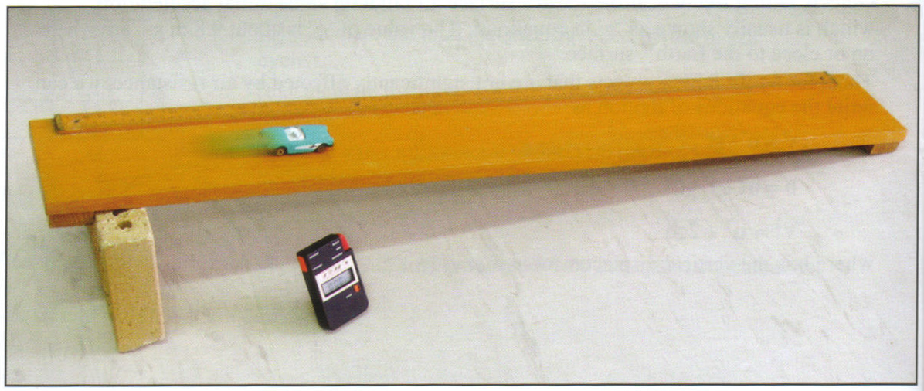

Figure 1: Set up of Experiment Equipment

**Laboratory Notes**

* It is important to start the vehicle from a stationary marked positioned at the top of the slope. This position will be identical for each repetition making the initial velocity as zero and initial time at zero.
* In each repetition, have one person record the time it takes to travel the full predetermined distance, while the other records the time it took for the car to travel the last 10cm of the predetermined run.
* Carry out several trials and record the data.
* Changing the slope and completing the experiment over again is a way of determining how the slope will affect the acceleration. Keep the angles less than 30o.
* Carry out the calculations to work out the speed or velocity of the vehicle at the preselected final 10cm.
* Record your data, noting that the time to run the full length of the slope is the time used on the speed or velocity versus time graph.
* Use the data you have recorded to make a line of best fit by eye, rather than joining the dots.
* Determine the gradient (slope) of the line of best fit, including the units of the gradient.

**Possible Post-Lab Discussion**

* What have you found out about the acceleration of your vehicle?
* The acceleration is a component of the acceleration due to gravity, and its magnitude (size) depends on the angle that the slope makes with the horizontal. Calculate the magnitude of the component of the gravity acceleration that is parallel to the slope. Compare this with the acceleration you worked out from your graph.
* Explain how you could use your results to predict:

1. how fast the vehicle will be moving at a time between two of the measurements you made.
2. how fast vehicle would have been travelling at a time 2 seconds after the last measurement you made.

**Conclusion**

Write a conclusion for your lab. You should refer to your original hypothesis, and to the dependent and independent variables.

**Marks Distribution**

|  |  |  |  |  |  |
| --- | --- | --- | --- | --- | --- |
| Section | Marks Available | Marks Received | Section | Marks Available | Marks Received |
| Aim | 1 |  | Method | 2 |  |
| Hypothesis | 4 |  | Results (exc Graph) | 4 |  |
| Prediction | 1 |  | Graph | 8 |  |
| Parameters | 3 |  | Discussion | 10 |  |
| Materials list | 2 |  | Conclusion | 5 |  |